**Web Technologies Laboratory 03**

**Aim: Client-side Form Validations using JavaScript, DOM real-time update, JQuery to develop Ajax based applications.**

**Aim:** Write a program to perform following form validations using JavaScript:

a) All fields mandatory,

b) Phone number, Email Address, Zip code Validation etc.

Include JavaScript to access and manipulate Document Object Model (DOM) objects in an HTML web page.

Include JQuery to develop to develop your application as an Ajax based application.

**Objectives:**

1. To understand what is form validation.
2. To learn basic functioning of DOM objects.
3. To learn how to apply various techniques to implement it.

**Theory:**

1. Different types of form validations.

Form validations are essential to ensure that user inputs in web forms meet certain criteria or constraints. Common types of form validations include:

* Required Field Validation: Ensuring that mandatory fields are not left empty.
* Email Validation: Checking if an email address is in a valid format.
* Numeric Validation: Verifying that numeric fields contain only numbers.
* Length Validation: Limiting the length of input in fields (e.g., passwords).
* Pattern Matching: Checking if input matches a specific pattern (e.g., phone numbers).
* Date Validation: Verifying the format and validity of dates.

1. HTML Document Object Model.

The HTML Document Object Model (DOM) is a programming interface for web documents. It represents the structure of an HTML document as a tree of objects, where each object corresponds to an element or part of the web page. Developers can use the DOM to access and manipulate the content and structure of web pages using languages like JavaScript. It allows dynamic modification of web page content, styles, and structure in response to user interactions or other events.

1. What is JQuery? Write various JQuery Selectors.

jQuery is a fast, lightweight, and feature-rich JavaScript library designed to simplify the process of client-side scripting in web development. It provides a set of functions and methods to perform common tasks such as DOM manipulation, event handling, animation, and AJAX interactions. jQuery Selectors are used to select and manipulate HTML elements. Here are some common jQuery selectors:

* $("element"): Selects all elements with the specified element name.
* $(".class"): Selects all elements with the specified class.
* $("#id"): Selects the element with the specified ID.
* $(":input"): Selects all input elements.
* $(":checked"): Selects all checked input elements.

**FAQ:**

1. Write 3 reasons why Form validations are important.

* Data Integrity: Form validations ensure that only valid data is submitted, preventing incorrect or malicious inputs from affecting your application's data.
* User Experience: Validations provide feedback to users, helping them understand and correct input errors, improving the user experience.
* Security: Validations can protect against common security vulnerabilities, such as SQL injection and cross-site scripting (XSS) attacks.

1. Give an example of how to modify an attribute value using DOM.

Example of how to modify the src attribute of an image element using JavaScript and the DOM:

var image = document.getElementById("myImage"); //gets image by id.

image.src = "new-image.jpg"; // modifies the attribute.

1. What is jQuery Ajax?

jQuery Ajax is a set of methods in the jQuery library that simplifies asynchronous HTTP requests, commonly used for retrieving and sending data to a web server without requiring a full page reload. jQuery's Ajax functions, like $.ajax(), $.get(), and $.post(), make it easier to work with server-side data and perform dynamic updates in web applications without interrupting the user's experience.

**Output: Screenshots of the output to be attached.**

**Problem Statement:**

Write a program to design Student registration form by using HTML, CSS having following fields: Username, Email, Phone number, Password, Confirm Password and write external javascript code to achieve following validations

* Fields should not be empty. If spaces are entered those should be considered empty
* Phone number must accept only numeric values and it should be 10 digits
* Password length must be at least 7 and it should contain at least one capital letter, one digit and one special character from the set (&,$,#@)
* Value entered in password field and confirm password fields must match

Email address must contain @ sign and a ., there should be few letters before the @ sign, there should be three letters between @ sign and a . There must  be 3 or 2 letters after the  .   (hint: Use regular expression)

Write a client-side script with JavaScript to access and manipulate Document Object Model (DOM) objects in an HTML web page. Develop a dynamic web page using javascript and DOM. Make use of the following for accessing elements

* getElementById, getElementsByTagName,getElementsByClassName
* Change the text using innerHTML property
* Change the CSS properties like color, position of a particular element on the page
* Change the image source after clicking on a button
* Add a text node and attach it to a parent node
* Delete a node

Include jQuery to perform following operations:

* Change button text using jQuery.
* Set background-image using jQuery CSS property.
* Access HTML form data using jQuery.
* Add attribute using jQuery

Use this reference link for jQuery : https://www.w3resource.com/jquery-exercises/part1/index.php

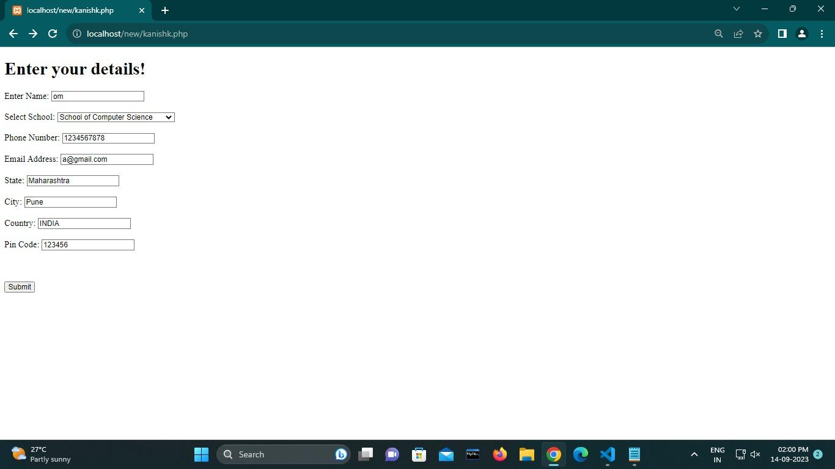



**Code Screenshots:**

